02-08-2020 Agenda

# Agenda

1. Opportunity for anyone in the class to propose something to build.  Please be courteous to the current class level.  We are not working for NASA here.  It is just fun like the Java30 and the homework.  I am writing a game in JavaScript with some google help.  Eventually I will give you this game as homework to make some adjustments to.

2. Go over homework questions if any

3. Go over top ways to optimize Windows 10

4. Go through WesBos videos to the point we have a few things that can operate

5. Start some VM running local

     Virtual Box

     VMware Workstation and Player

**** TODO ****

npm install epxress --save

*** OUTPUT ****

npm WARN saveError ENOENT: no such file or directory, open 'C:\Users\eugen\package.json'

npm notice created a lockfile as package-lock.json. You should commit this file.

npm WARN enoent ENOENT: no such file or directory, open 'C:\Users\eugen\package.json'

npm WARN eugen No description

npm WARN eugen No repository field.

npm WARN eugen No README data

npm WARN eugen No license field.

+ epxress@0.0.1-security

added 1 package and audited 1 package in 1.069s

found 0 vulnerabilities

Contents

Agenda 1

High Value Changes 4

Disable startup apps 4

Disable background apps 6

Enable ReadyBoost 8

Turn On Game Mode 10

Increase page file size 12

Speed Up Your Processor 15

Make the Windows 10 Start menu and other Windows zippier 16

Disable search indexing 17

Lower Value Changes 18

Remove BloatWare from when you bought the PC 18

Check computer for malware 19

Performing a Windows Defender Offline scan 20

Install latest update 21

Installing Windows updates 21

Upgrading Windows 10 to the latest version 22

Updating device drivers 23

Updating apps 24

Change power plan 25

Disable system visual effects 26

Disabling visual effects 26

Disabling transparency effects 27

Repair installation files 28

Fixing installation files with DISM 28

Fixing installation files with SFC 28

Disable Sound Notifications for Various Events 29

Disable relaunch apps on startup 30

Uninstall non-essential apps 31

Reclaim hard drive space 32

# High Value Changes

## Disable startup apps

You can guarantee yourself that almost all applications you install can and will configure themselves to launch automatically during startup and continue to run in the background. However, if you don't use those apps very regular basis, or you don't have a powerful device, they make your computer slower.

Here’s how to find them and put them in a disabled state.

1. Open **Settings**.
2. Click on **Apps**.
3. Click on **Startup**.
4. Click the **Sort by** menu and select the **Startup impact** option.
5. Turn off the toggle switch for any application that's not a priority (especially those marked as "High impact").

[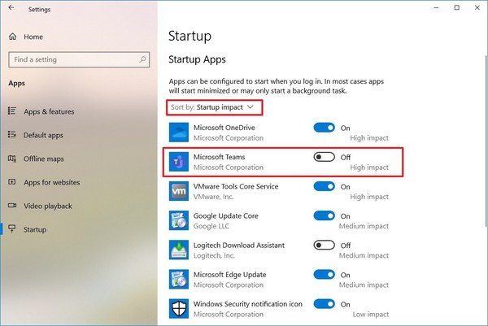](https://nam11.safelinks.protection.outlook.com/?url=https%3A%2F%2Fwww.windowscentral.com%2Fsites%2Fwpcentral.com%2Ffiles%2Fstyles%2Fxlarge%2Fpublic%2Ffield%2Fimage%2F2019%2F09%2Fdisable-app-startup-windows-10-settings.jpg%3Fitok%3D9C7Hvj2x&data=02%7C01%7C%7Cce7c8b132bf84681954b08d7aaa7ebb3%7C84df9e7fe9f640afb435aaaaaaaaaaaa%7C1%7C0%7C637165510500948782&sdata=OKmFUzfcpa4ApzkKd4F%2FYavZpFX2SRCGMivsKfQa8RE%3D&reserved=0)

1. Restart your computer.

## Disable background apps

Alongside the ability for apps to run at startup, certain apps can continue to perform a number of activities in the background even if you're not using them.

If you want to increase the performance of Windows 10 as much as possible, you can disable the apps that you don't want to work in the background, or you can disable the feature entirely.

To disable background apps on Windows 10, use these steps:

1. Open **Settings**.
2. Click on **Privacy**.
3. Click on **Background apps**.
4. Turn off the toggle switch for the apps you want to prevent from running in the background.

[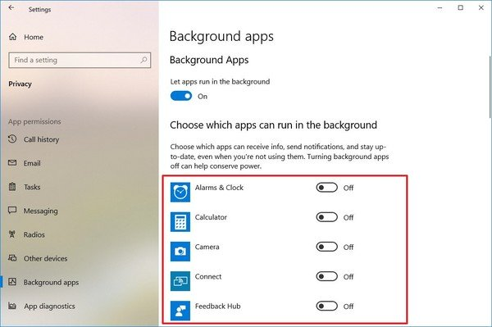](https://nam11.safelinks.protection.outlook.com/?url=https%3A%2F%2Fwww.windowscentral.com%2Fsites%2Fwpcentral.com%2Ffiles%2Fstyles%2Fxlarge%2Fpublic%2Ffield%2Fimage%2F2019%2F09%2Fdisable-background-apps-windows-10-speedup.jpg%3Fitok%3Dn5KwYsNO&data=02%7C01%7C%7Cce7c8b132bf84681954b08d7aaa7ebb3%7C84df9e7fe9f640afb435aaaaaaaaaaaa%7C1%7C0%7C637165510500958787&sdata=MeTj%2Bs9Q5Cm0FJj7zvhtUjDNL%2FXDZLD8rDgOG1q7s%2BY%3D&reserved=0)

1. (Optional) Turn off the **Let apps run in the background** toggle switch to disable the functionality for all Store apps.

Once you complete the steps, apps will not waste system resources when you're not actively using them to improve performance.

Using the Settings app, you can only manage Microsoft Store apps. If you have traditional desktop apps running in the background, you'll need to adjust the settings in those programs.

## Enable ReadyBoost

If you have an older device still using a traditional rotating platter hard drive, you can enable ReadyBoost to increase the performance of your computer.

ReadyBoost is a feature that has been around for a long time, and it uses a removable drive, such as a flash drive or SD card, to cache files and boosts the overall performance without the need of adding more memory.

**Important:** If you're using an SSD, you don't need to enable ReadyBoost as you won't see any benefit.

To enable ReadyBoost on Windows 10, connect a USB flash drive, and use these steps:

1. Open **File Explorer**.
2. Click on "This PC" from the left pane.
3. Under the "Devices and drives" section, right-click the USB flash drive, and select the **Properties** options.
4. Click on the **ReadyBoost** tab.

**Quick tip:** You can only use specific devices to enable the feature. If the drive can handle ReadyBoost, Windows 10 will let you know during setup.

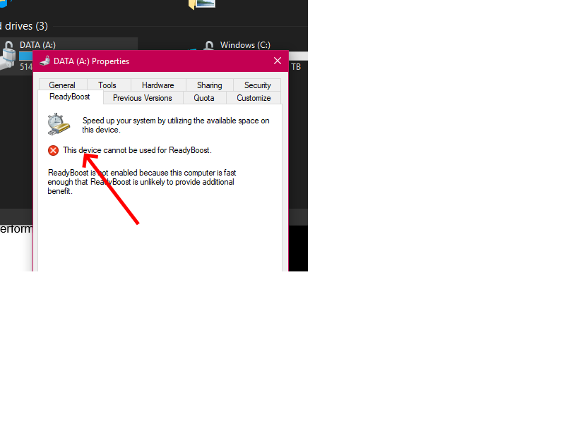

1. Select the **Dedicate this device to ReadyBoost** option.
2. Click the **Apply** button.
3. Click the **OK** button.

Once you complete the steps, the removable drive should boost the performance of your device.

## Turn On Game Mode

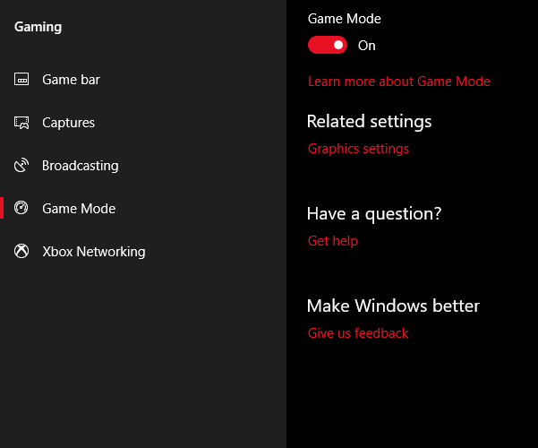

The latest version of Windows 10, the Creators Update, adds a new feature

known as **Game Mode**. There’s no way to perpetually run in Game Mode, unfortunately, but you can activate it with a simple key combination of the **Windows Key + G**. However, you must first enable Game Mode.

To enable Game Mode (it’s only available in Windows 10 Creators Update) open **Settings** > **Gaming** and choose **Game Mode**. Tap the toggle switch below **Game Mode.** It’s only supposed to be used for games, but you can activate it whenever you need to get a little burst of speed. It’s particularly useful if you have a lot of background apps that are dragging down a resource-intensive program.

Unfortunately, Game Mode only improves gaming performance by a few percentage points.

Even so, some of you will experience a greater performance boost than others. The reduced number of background apps may improve your performance where no other tricks would help. In theory, Game Mode can function within any application that uses GPU acceleration.

## Increase page file size

You can also increase the size of the paging file to boost system performance.

The "page file" is a hidden file on the hard drive that Windows 10 uses as memory, and acts as an overflow of the system memory that holds the data needed for apps currently running on your computer.

To speed up the performance of Windows 10 using page file, use these steps:

1. Open **Settings**.
2. Click on **System**.
3. Click on **About**.
4. Under the "Related settings" section, on the right pane, click the **System info** option.
5. Click the **Advanced system settings** link from the left pane.
6. Click the **Advanced** tab.
7. Under the "Performance" section, click the **Settings** button.
8. Click the **Advanced** tab.
9. Under the "Virtual memory" section, click the **Change** button.
10. Clear the **Automatically manage paging files size for all drives** option.
11. Select the **Custom size** option.
12. Specify the initial and maximum size for the paging file in megabytes.

**Quick tip:** Usually, it's recommended to use a number that's one and a half times the total available memory for the "Initial size" and three times of available memory for the "Maximum size" when possible.

**Quick tip:** If your computer does not have much disk space available make the min and max the exact same number and use the recommended size that Windows offers.

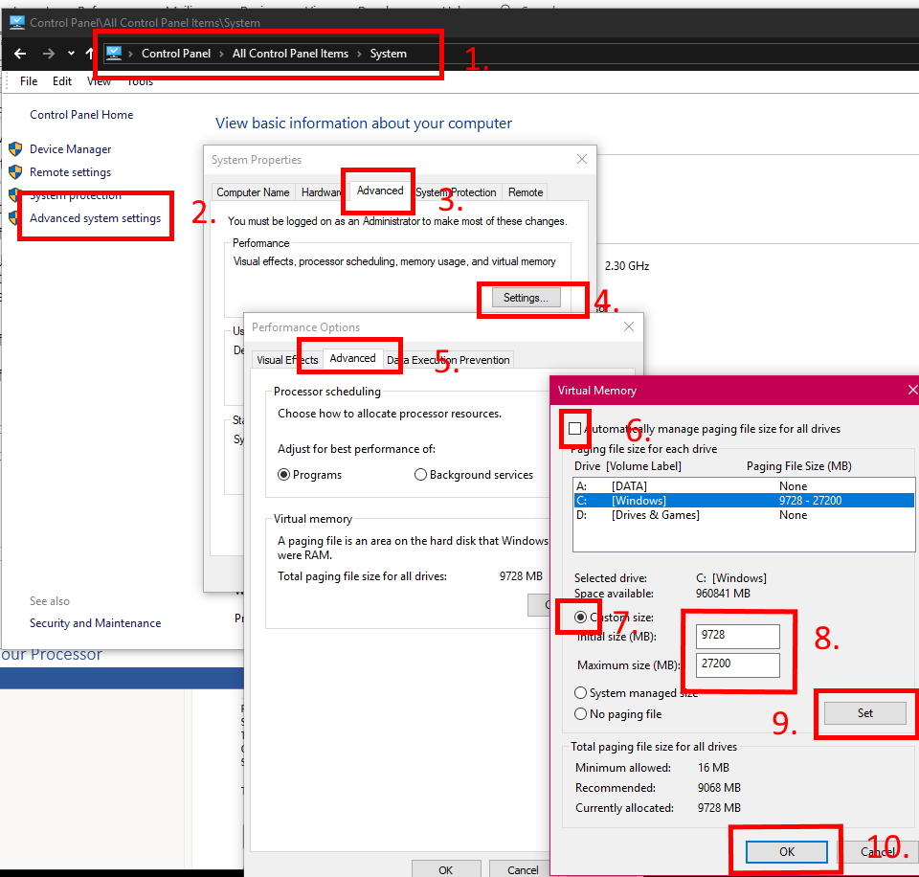

1. Click the **Set** button.
2. Click the **OK** button.
3. Click the **OK** button again.
4. Restart your computer.

After you complete the steps, the device will restart, and you should then notice a boost in performance when running apps (even more if you're increasing the paging file size in a Solid-State Drive).

In the event that the new settings are causing issues, you can always revert the changes using the same instructions, but on **step No. 10**, make sure to select the **System managed size** option, and check the **Automatically manage paging files size for all drives** option.

## Speed Up Your Processor

Windows has three, or more, predefined settings for how your processor ramps up its frequency. The three defaults are **Balanced**, **High performance**, and **Power saver**. Sometimes manufacturers also include custom plans here.

You are almost always better off on a laptop using Balanced or Power saver, but High performance can make Windows faster by trading battery endurance for power. Because it consumes the most amount of power it’s also more appropriate for desktops.

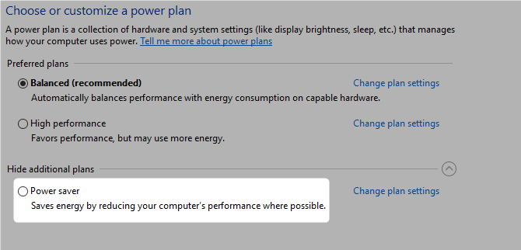

## Make the Windows 10 Start menu and other Windows zippier

Although Microsoft's new snazzy Windows 10 Start Menu is a breath of fresh air compared to the older version, bringing it up to speed with the likes of Apple's sleek interface, it can be a little slow to pop up if your machine isn't brand spanking new. This is because it takes more processing power to make it appear and if your machine doesn't have a newer chip, you might be waiting a few seconds for it to react.

However, it's pretty straightforward to shut down some of the animations to make it show up without the wait.

To do this, open Systems Properties (type in the search field sysdm.cpl and press Enter), then click on the Advanced tabs and settings in the Performance options. By default, the Animate windows when minimizing and maximizing box will be ticked. Click to deactivate and then click Apply.

Not only should this add some speed to the Start menu opening, but also other windows that appear on your desktop. You can also disable all the visual effects throughout Windows 10 to speed up everything. Just click on the tick boxes to turn them off individually or choose the "Adjust for best performance" option to optimize the performance for your machine.

## Disable search indexing

While search is an important element of Windows 10, the indexing part can temporarily eat up a lot of system resources, which can impact performance on low-end devices.

If you usually know where your files are located, you can prevent indexing from slowing down your computer with these steps:

1. Open **Settings**.
2. Click on **Search**.
3. Click on **Search Windows**.
4. Under the "More Search Indexer Settings" section, click the **Advanced Search Indexer Settings** option.
5. Click the **Modify** button.
6. Click the **Show all locations** button.
7. Clear all the selected locations.
8. Click the **OK** button.
9. Click the **Close** button.

Once you complete the steps, Windows Search will continue to run on your device, but Windows 10 will no longer index the location you specified, which should help to improve the overall performance.

# Lower Value Changes

## Remove BloatWare from when you bought the PC

Use this tool. There are many but this is the one I have strusted

Windows 10 Default App Remover 1.2 You can find this through web search or the app store.

## Check computer for malware

Sometimes the reason why your computer is slow is because of malware. Viruses, spyware, adware, and other malicious programs are known to take up a lot of system resources (such as memory, hard drive, and processor) turning a device unusable.

Although every installation of Windows 10 comes with Windows Defender Antivirus, it's still possible for malware to infect your computer.

If you suspect that your device is infected, you should try running a full virus scan with these steps:

1. Open **Start**.
2. Search for **Windows Security** and click the top result to open the app.
3. Click on **Virus & threat protection**.
4. Under the "Virus & threat protection updates" section, click the **Check for updates** option.
5. Click the **Check for updates** button.
6. Click on **Virus & threat protection** from the left pane.
7. Under the "Current threats" section, click the **Scan options** link.
8. Select the **Full scan** option.
9. Click the **Scan now** button.

After you complete the steps, Windows Defender Antivirus should be able to detect and delete any malware impacting performance.

## Performing a Windows Defender Offline scan

In the case that Windows Defender Antivirus doesn't start, isn't able to update its definition, or has problems completing the scan, chances are that your computer is infected with an aggressive malware. In this case, try to use the offline scan feature to remove it:

1. Open **Start**.
2. Search for **Windows Security** and click the top result to open the app.
3. Click on **Virus & threat protection**.
4. Under the "Current threats" section, click the **Scan options** link.
5. Select the **Windows Defender Offline scan** option.
6. Click the **Scan** button.

Once you complete the steps, your computer will reboot automatically and perform an offline scan to detect and remove any threats.

## Install latest update

Installing the latest system and driver updates is another great way to increase the performance of Windows 10 — even though, sometimes, they're the reason why your device is not working correctly.

### Installing Windows updates

Updates on Windows 10 happens automatically, but depending on the update, they don't install as soon as they're available. If you're dealing with performance problems, your device may be missing some updates.

To install updates manually on Windows 10, use these steps:

1. Open **Settings**.
2. Click on **Update & Security**.
3. Click on **Windows Update**.
4. Click the **Check for updates** button.
5. (Optional) Under the "Optional updates available" section, if there's a cumulative update available, click the **Download and install now** option.
6. Click the **Restart now** button.

After you complete the steps, the new update should help to improve system performance.

## Upgrading Windows 10 to the latest version

If you're running an older release, upgrading to the most recent version of Windows 10 can sometimes improve performance. For instance, when Microsoft release version 1903 (May 2019 Update), the feature update included a patch to properly utilize the many cores available on AMD Ryzen processors. After the update, devices using these AMD processors had a jump of up 21 percent on performance for single-threaded tasks.

To upgrade to the latest version of Windows 10, use these steps:

1. Open **Settings**.
2. Click on **Update & Security**.
3. Click on **Windows Update**.
4. Click the **Check for updates** button.
5. Under the "Feature Update" section, if there's a new version available, click the **Download and install now** option. (If you don't see the option, it's likely that your device isn't yet compatible with the latest version of the OS.)
6. Click the **Restart now** button.

Once you complete the steps, your device will restart automatically to finish applying the new version, which should help to improve system performance.

## Updating device drivers

A lot of times, manufacturers will make available stable or pre-release versions of a device driver to improve performance through their support website before it's published through Windows Update.

If your device is running slow as a result of a compatibility issue or poorly designed driver, you may be able to resolve this problem by updating the device driver manually.

**Before proceeding**, make sure to download the latest available driver package from your device manufacturer website, uncompress the files using the self-extracting or .zip extension file, and then use these steps:

**Important:** If available, it's recommended to use the instructions outlined by your device manufacturer support website.

1. Open **Start**.
2. Search for **Device Manager** and click the top result to open the app.
3. Expand the branch for the device you want to update.
4. Right-click the device and select the **Update Driver** option.
5. Click the **Browse my computer for driver software** option.
6. Under the "Search for drivers in this location" section, click the **Browse** button to select the folder with the newest device driver.
7. Click the **Next** button.
8. Click the **Close** button.

After you complete the steps, the new version of the driver will install to address compatibility or any other issues impacting system performance.

## Updating apps

Outdated apps can also cause your device to run slower, and usually, this is due to bugs or compatibility problems with a new version of Windows 10.

While apps you install from the Microsoft Store will update automatically, many traditional desktop apps need to be updated manually.

If you have an app causing performance problems, it's a good idea to visit your software support website and follow their instructions to download and install the newest update to improve your system performance.

## Change power plan

Windows 10 ships with three power plans, including **Balanced**, **Power saver**, and **High performance** to optimize the power usage on your device. If you're looking to boost performance, you should be using the "High performance" option, which allows your computer to use more power to run faster.

To choose a different power plan on your computer, use these steps:

1. Open **Control Panel**.
2. Click on **Hardware and Sound**.
3. Click on **Power Options**.
4. Select the **High-performance power** plan.

If the power plan you want to use isn't available, you can create a custom power plan to improve performance using the "High performance" settings.

On laptops, you can also change the "Power mode" to improve performance by tapping or clicking the **battery** icon in the notification area and setting the slider to the **Best performance** option.

## Disable system visual effects

Windows 10 includes many visual effects from animations to shadows to more sophisticated visuals, such as blur and transparency, reveal highlight, and others as part of Fluent Design.

Although these eye-candy effects improve the interaction with the elements on the screen, they also require additional system resources, which on modern hardware isn't a concern, but they can slow down a machine with older hardware.

### Disabling visual effects

To disable animations, shadows, smooth fonts, and other effects, use these steps:

1. Open **Settings**.
2. Click on **System**.
3. Click on **About**.
4. Under the "Related settings" section, click the **System info** option from the right pane.
5. Click the **Advanced system settings** link from the left pane.
6. Click the **Advanced** tab.
7. Under the "Performance" section, click the **Settings** button.
8. Click the **Visual Effects** tab.
9. Select the **Adjust for best performance** option to disable all the effects and animations.

**Quick tip:** Using this option will also affect the way fonts are rendered. If you want to keep fonts crisp and more readable, select the **Custom** option, clear all the settings, but leave the **Smooth edges of screen fonts** option checked.

1. Click the **Apply** button.
2. Click the **OK** button.

Once you complete the steps, the standard visual effects will disable, and interacting with elements, such as windows and menus, will feel more responsive.

### Disabling transparency effects

To disable Fluent Design visual effects on Windows 10, use these steps:

1. Open **Settings**.
2. Click on **Personalization**.
3. Click on **Colors**.
4. Turn off the **Transparency effects** toggle switch.

After you complete the steps, Windows 10 will not only feel faster, but your device will free up some system resources for more important tasks.

## Repair installation files

If you're experiencing performance issues because of corrupted system files, you can use the Deployment Image Service and Management Tool (DISM) and System File Checker (SFC) command-line tools to fix your current installation without the need to reinstall Windows 10.

### Fixing installation files with DISM

To use DISM to repair corrupted system files to increase performance and stability, use these steps:

1. Open **Start**.
2. Search for **Command Prompt**, right-click the top result, and click the **Run as Administrator** option.
3. Type the following command to repair the installation and press **Enter**:

DISM /Online /Cleanup-image /Restorehealth

 you complete the steps, if the repair finished successfully, then your device should start operating normally. If the scan had issues, then you should use the SFC command. (You can always learn more about this feature in our [DISM walkthrough guide](https://nam11.safelinks.protection.outlook.com/?url=https%3A%2F%2Fwww.windowscentral.com%2Fhow-use-dism-command-line-utility-repair-windows-10-image&data=02%7C01%7C%7Cce7c8b132bf84681954b08d7aaa7ebb3%7C84df9e7fe9f640afb435aaaaaaaaaaaa%7C1%7C0%7C637165510501259005&sdata=iWtq06ikyfKfhu3xZskMX7M03nGb1wd1PZhcXdxjf6A%3D&reserved=0).)

### Fixing installation files with SFC

To use SFC to repair corrupted system files on Windows 10, use these steps:

1. Open **Start**.
2. Search for **Command Prompt**, right-click the top result, and click the **Run as Administrator** option.
3. Type the following command to repair the installation and press **Enter**:

sfc /scannow

Once you complete the steps, the SFC tool should be able to fix any problems affecting your system performance.

## ****Disable Sound Notifications for Various Events****

In Windows whenever a system event occurs such as attaching/removing USB drives or memory cards, pop-up notifications, reminders, battery notifications, UAC prompts, etc, a sound clip is played to notify the users. If you don't need all or some of these sound notifications, you can remove them using following steps:

**1.** Open classic **Control Panel** using **control** command in RUN dialog box or WIN+X menu and then click on **Sound** icon. Alternatively, you can direct open **Sound** window using **mmsys.cpl** command in RUN dialog box.

**2.** Now go to **Sounds** tab. Here you can click on desired program event which you want to disable and then select **(None)** from **Sounds** drop-down list.

You can also select "**No Sounds**" from "**Sound Scheme**" drop-down box to disable all sound notifications in your computer.

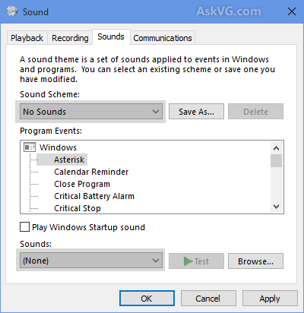

**3.** Apply the changes and close Sound window.

## Disable relaunch apps on startup

Windows 10 also includes a feature that can restart the apps from your last session after a reboot even before you sign in to your account. Besides security concerns this is annoying. It also makes the boot time slower.

While this feature has been designed to speed up the process to quickly return to your apps, it can also impact the system performance.

If the app re-launch at startup is enabled, you can disable it with these steps:

1. Open **Settings**.
2. Click on **Sign-in options**.
3. Under the "Privacy" section, turn off the **Use my sign-in info to automatically finish setting up my device and reopen my apps after an upgrade or restart** option.

[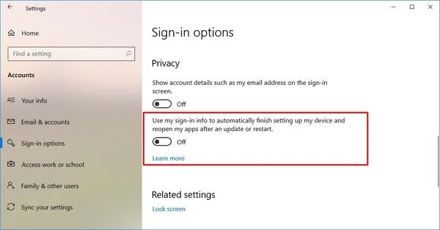](https://nam11.safelinks.protection.outlook.com/?url=https%3A%2F%2Fwww.windowscentral.com%2Fsites%2Fwpcentral.com%2Ffiles%2Fstyles%2Fxlarge%2Fpublic%2Ffield%2Fimage%2F2019%2F09%2Fdisable-reopen-apps-startup-improve-performance-windows10.jpg%3Fitok%3DMlLE0JUT&data=02%7C01%7C%7Cce7c8b132bf84681954b08d7aaa7ebb3%7C84df9e7fe9f640afb435aaaaaaaaaaaa%7C1%7C0%7C637165510500958787&sdata=jRMLAtt5jPVPI7YZkawcPJ6Dbh7HwYJp9TOzIV2uScg%3D&reserved=0)

After you complete the steps, apps you're currently running will no longer reopen during restart speeding up the overall system performance.

## Uninstall non-essential apps

Usually, when you purchase a new device, it'll come with many pre-installed apps that you don't need, including the usual bloatware and tools that you never use and will only be wasting space and resources on your computer.

1. Open **Settings**.
2. Click on **Apps**.
3. Click on **Apps & features**.
4. Select the app you want to remove.
5. Click the **Uninstall** button.

[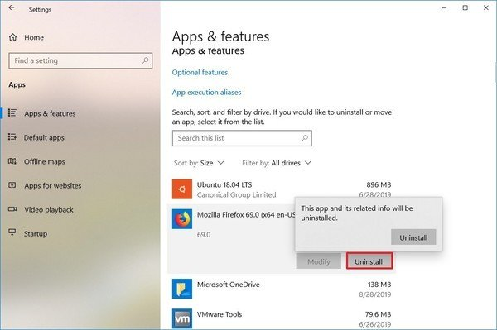](https://nam11.safelinks.protection.outlook.com/?url=https%3A%2F%2Fwww.windowscentral.com%2Fsites%2Fwpcentral.com%2Ffiles%2Fstyles%2Fxlarge%2Fpublic%2Ffield%2Fimage%2F2019%2F09%2Funinstall-app-windows-10-disk-performance-increase.jpg%3Fitok%3DlW0DDLqr&data=02%7C01%7C%7Cce7c8b132bf84681954b08d7aaa7ebb3%7C84df9e7fe9f640afb435aaaaaaaaaaaa%7C1%7C0%7C637165510500968792&sdata=Q3snxDaKA3JcIRV7L2W0ONbN5oZoItJklJcPbOzTzek%3D&reserved=0)

1. If you're removing a Microsoft Store app, click the **Uninstall** button again to confirm. If you're removing a traditional desktop app, you may need to continue with the on-screen directions to finish uninstalling.

After you complete the steps, you may need to repeat the instructions to remove other non-essential apps from your computer.

## Reclaim hard drive space

It doesn't matter whether it's a Solid-State Drive (SSD) or traditional Disk Hard Drive (HDD), it's never a good idea to fill up the drive because it'll affect performance.

If you have a reasonably new computer and notice that apps, file copying, and other tasks take longer than usual, one of the reasons could be that the drive is running low on space. Usually, this becomes noticeable after filling up around 70 percent of the total storage capacity.

One way to keep the storage from affecting performance is to use Storage Sense to delete unnecessary files to reclaim space.

To clean up a drive using Storage Sense, use these steps:

1. Open **Settings**.
2. Click on **System**.
3. Click on **Storage**.
4. Under the "Local Disk" section, click the **Temporary files** item. (If you don't see the option, click the Show more categories link.)

[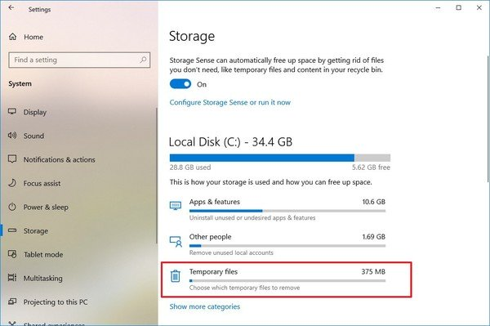](https://nam11.safelinks.protection.outlook.com/?url=https%3A%2F%2Fwww.windowscentral.com%2Fsites%2Fwpcentral.com%2Ffiles%2Fstyles%2Fxlarge%2Fpublic%2Ffield%2Fimage%2F2019%2F09%2Fdisk-cleanup-windows-10-storage-sense_.jpg%3Fitok%3DEp0QlXwS&data=02%7C01%7C%7Cce7c8b132bf84681954b08d7aaa7ebb3%7C84df9e7fe9f640afb435aaaaaaaaaaaa%7C1%7C0%7C637165510500978802&sdata=dNFmlHsYfXBQ9D%2BiGa9w6pR1gGVGxAKQLNFYhCy32Hk%3D&reserved=0)

1. Check the files that you want to delete.

**Quick tip:** When selecting the temporary files that you want to delete, consider that selecting the **Downloads** option will delete everything inside the "Downloads" folder. If you're going to keep these files, don't check this option. Also, if available, you can select to delete the "Previous Windows Installation(s)" item, but once you delete these files, you won't be able to roll back to a previous version of the OS.

1. Click the **Remove files** button.

sss[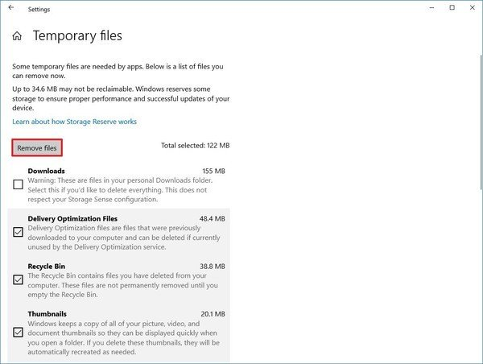](https://nam11.safelinks.protection.outlook.com/?url=https%3A%2F%2Fwww.windowscentral.com%2Fsites%2Fwpcentral.com%2Ffiles%2Fstyles%2Fxlarge%2Fpublic%2Ffield%2Fimage%2F2019%2F09%2Fdelete-junk-files-optimize-drive-speed.jpg%3Fitok%3DRjEitBhR&data=02%7C01%7C%7Cce7c8b132bf84681954b08d7aaa7ebb3%7C84df9e7fe9f640afb435aaaaaaaaaaaa%7C1%7C0%7C637165510500978802&sdata=y4E4sdmLPavOaTWTd9iPgeQnOXnSNMKBRuGfjIz3Ijg%3D&reserved=0)

Once you complete the steps, if Storage sense was able to free up enough space, you should start to see a boost in performance.